
Università degli Studi di Genova
Scuola Politecnica & Facoltà di Ingegneria
_________________________________________________

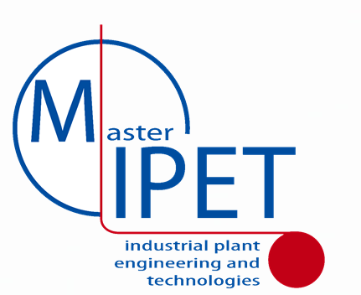

Mastering Industrial Plant Engineering & Technologies

International Master in Engineering of Genoa University

_________________________________________________

[TITLE]
_______________________________________________
Advisor: [Prof./Dr./Mr. XXX YYY, Affiliation]
Candidate : [Dr./Mr. XXX YYY]

Academic Year MMXVII
MIPET 8th Edition
Acknowledgements

Abstract

[max 500 words]

Preface

TABLE OF CONTENTS

INTRODUCTION

[Why, What, Where this work was carried out]
CHAPTHER 1 - INDUSTRIAL FRAMEWORK

[The industrial context for your work in term of business sector, technical framework, engineering solutions, regulations, market, etc.]

[Text Example (please use Font Arial 10)
The Peter Kiewit Institute provide the possibility to extensively demonstrate and test models and solution for applications of simulators; and even if the Experience in Omaha R&D Center was shorter than expected, it was possible to complete the demonstration of the interoperable simulators devoted to cooperative training in industrial facilities [Bruzzone 1998]; in addition the experimentation on CUMANA Project was completed with a team of engineers in order to compare the result obtained in Seattle with Boeing. The analysis of the data was based on DOE and statistical analysis [Bruzzone, Mosca 2003; Kliem et al.1997].

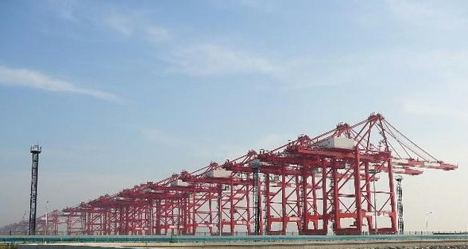
Figure 1.1:Yangshan Container Terminal subjected to Simulation Models

Table IV – Kit Distribution
Kit Distribution | %
Empenage | 1
Wing | 5
Body | 76
Body Join | 18

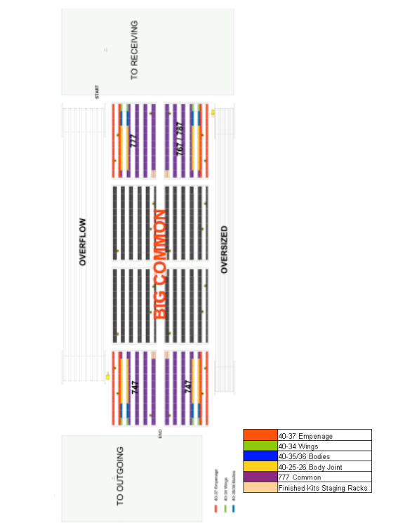
Figure 1.42:General Layout

CHAPTHER 2 - INTERNSHIP

[Internship Description]

CHAPTHER 3 - INDUSTRIAL PLANT

[Industrial Plant, Component, Skid or Project under analysis]

In case you worked on classified or confidential data please include in the text the following sentence and act in consequence:

The following data have been modified/altered due to confidential nature of these issues
Please consider to cancel unit of measures, modify numbers and values, obscure layout and drawings, etc if it is required in order to guarantee IPR (Intellectual Proprietary Rights) and/or confidential info.
CHAPTHER X - [TITLE]

CHAPTHER X+1 - [TITLE]

CONCLUSIONS

[Synthesis of what you have done and the result achieved, benefits, gap]

LESSONS LEARNED

[What it was possible to learn on the subject of your thesis; gaps, errors, discoveries identified during this study]
FUTURE DEVELOPMENTS

[Future step forward highlighted by the current work]
TECHNICAL & SCIENTIFIC REFERENCES
[Reference to all the works that you used]
- Arcibald R.D. (1994) "Project management. La gestione di progetti e programmi complessi", Franco Angeli, Milan
- Asbury S. (2007) "Health & Safety, Environment and Quality Audits: A risk-based approach", Butterworth-Heinemann, Oxford, ISBN 0750680261
- Bartelt T.L.M. (2006) "Instrumentation and Process Control", Delmar Cengage Learning, Florence KY, ISBN 1418041718
- Bausbacher E, Hunt R. (1993) "Process Plant Layout and Piping Design",Prentice Hall PTR, Upper Saddle River, NJ, ISBN 0131386298
- Bronson R., Naadimuthu G. (1997) "Operations Research", McGraw Hill, NYC
- Bruzzone A.G., Kerckhoffs (1996) "Simulation in Industry", SCS Publishing House, Ghent, Vol. I & II, ISBN 1-56555-099-4
- Bruzzone A.G. (1998) "Gestione dei Progetti d'Impianto", DIPTEM Academic Press, Genoa, Italy
- Bruzzone A.G., Mosca R. (2003) "Modelling & Applied Simulation", DIPTEM Press, Genoa, ISBN 88-900732-3-3 (197pp)
- Bruzzone A.G., Frydman C., Junco S., Dauphin-Panguy G. (2005) "Integrated Modelling and Analysis in Applied Control and Automation", LSIS Press, ISBN 2-9520712-5-X (pp 194)
- Bruzzone A.G., Cunha G.G., Landau L., Saetta S. (2006) "Applied Modelling & Simulation", LAMCE Press Rio de Janerio, ISBN 85-285-0089-6 (240 pp)
- Clemen R.T, Reilly T. (2001) "Making Hard Decisions", Duxbury, Pacific Grove CA
- Delmar Cengage Learning, Florence KY, ISBN 1418039998
- Duncan W. (1996) "Project Managment Body of Knowledge", Project Management Institute, Charlotte, NC, USA
- Dunn W. (2005) "Fundamentals of Industrial Instrumentation and Process Control", McGraw-Hill Professional, NYC, ISBN 0071457356
- Green W.D., Perry R.H.(2008) "Perry's Chemical Handbook", McGraw Hill, NYC
- Gousty Yvon (1997) "Le Genie Industriel", Presse Universitaire Paris
- Gross J.M. (2002) "Fundamentals of Preventive Maintenance", Amacom, NYC
- Heragu S. (1997) "Facilities Design", PWS Publishing Company, Boston
- Higgings P., Baird P.A., Barnes.M., Bates A.J.,Blacker A.J.M., Cousins P.T., Eames L.T., Forward F., Perry J.G., Shaw N.C., Weddell T.W. (2006) "Engineering and Construction Contract", NEC Technical Report, Thomas Telford Ltd, Institution of Civil Engineers, Glasgow UK
- Kerzner H. (1998) "Project Management", Van Nostrand Reinhold, New York
- Kerzner H. (2009) "Project Management: Case Studies", John Wiley & Sons, New York
- Kimmons R.L. (1990) "Project Management Basics", Marcel Dekker Inc.
- Kliem R.L. Robertson K.L. Lundin I.S. (1997) "Project Management Methodology", Marcel Dekker Inc.
- Menon S. (2004) "Piping Calculations Manual", McGraw-Hill Professional, NYC, ISBN 0071440909
- Monks J., (1996) "Operation Management", McGraw Hill, NYC
- Montgomery D.C. (2000) "Design and Analysis of Experiments", John Wiley & Sons, New York
- Navarrete P.F. (1995) "Planning, Estimating and Control of Chemical Construction Process", Marcel Dekker
- Pierce D.R. (1998) "Project Scheduling and Management for Construction, Means Co, Kingston MA
- Speegle M. (2007) "Process Technology Systems", Delmar Cengage Learning, Florence KY
- Speegle M. (2005) "Safety, Health, and Environmental Concepts for the Process Industry", Delmar Cengage Learning, Florence KY
- Spiegel M.R., Schiller L.J.(1999) " Statistics", McGraw Hill, NYC
- Taleb N.N. (2010) "The Black Swan", Random House, NYC
- Thomas C.E. (2006) "Process Technology Equipment and Systems: Equipment & Systems", Delmar Cengage Learning, Florence KY
- Web Site: http://www.itim.unige.it/cs/plants, 20.8.2012
- Web Site: http://www.itim.unige.it/pm, 2.2.2012
- Willoughby (1995) "Project management for Builders & Contractors", Salal Press
- Zandin K.B. (2001) "Maynard's Industrial Engineering Handbook", McGraw Hill, NYC

